Despatch:
- Add Type of order – S ( ASAP special order)
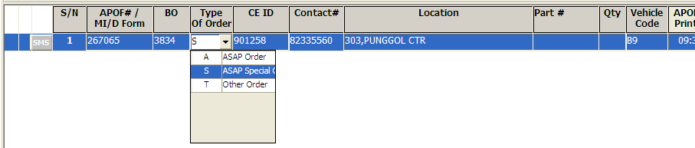

- ASAP Report : if type of order = ‘S’ , refer to Total TAT based on Vehicle leave to CE Received
